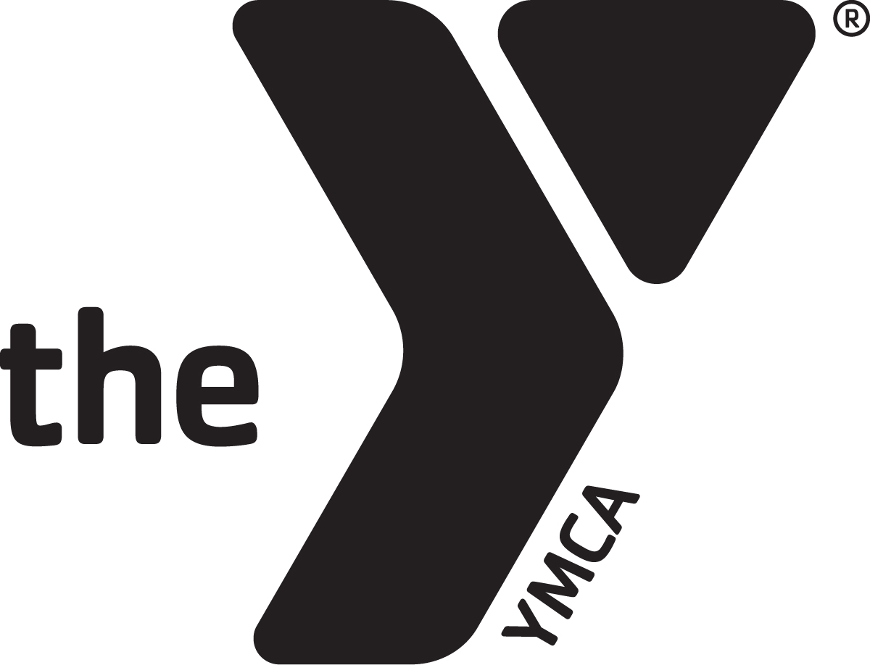

following characteristics:

* Be enrolled in high school and maintain a   
  3.0 or higher GPA
* Actively participate and demonstrate leadership in one or more   
  extra-curricular activities OR is taking an active role to improve   
  the overall health of their community. Activities may   
  be at school, another non-profit,   
  or at their church.
* Be 16-19 years old.

Our youth are not only the leaders of tomorrow, they are the leaders of today. The YMCA Antonio Little Teen Leadership Award is an annual award provided to a young individual between the ages of 16 to 19 that has exemplified leadership within the Rockford community.

The award will be presented at the YMCA of Rock River Valley’s Community Dinner on March 5, 2020.

Nominees for this award should exhibit the

$1,000 Scholarship Opportunity

TEEN LEADERSHIP AWARD

ANTONIO LITTLE

YMCA

To submit your nomination, please email the attached forms by February 1, 2020 to

YMCA OF ROCK RIVER VALLEY

Attn: Sharon Mattis

missionadvancement@rockriverymca.org

YMCA ANTONIO LITTLE TEEN LEADERSHIP APPLICATION

Completed & typed applications must be received no later than February 1, 2020.

Name Date of Birth

Address City State Zip

Phone Email

School Attending GPA

List all extra-curricular activities and leadership positions (or attach resume with information included):

List any community involvement (or attach resume with information included):

Please attach a typed essay of 500 words or less describing what a leader means to you and how you exemplify these qualities. Provide examples through storytelling. Also include attached letter of recommendation.

Send completed application/essay to:

Sharon Mattis

YMCA of Rock River Valley

220 East State Street, 4th Floor

Rockford, IL 61104

Email: missionadvancement@rockriverymca.org

Phone: (779) 500-0800